SPEC NOTE: This specification includes materials and installation procedures for the application of Durex® Dur-A-Static 535 Conductive Floor System, a seamless, self-leveling epoxy flooring system designed to provide conductive electrostatic discharge (ESD) protection in areas where static electricity must be controlled. Durex® Dur-A-Static 535 System designed for use as a high build, durable, wear resistant topcoat in a static discharge system that provides electric conductive resistance to protect sensitive electronic equipment and machinery. The system performs to a range of 2.5 x 10 to 1.0 x 10⁶ ohms, which is sustained throughout the 2mm Durex® Dur-A-Static SL 535 coating. The system consists of Priming/leveling layer, which is then combined with conductive grounded copper wire, Durex Dur-A-Static ESD 100 intermediate conductive coat and Durex® Dur-A-Static SL 535.

PART 1 GENERAL

1.1 GENERAL REQUIREMENTS

- All conditions of the contract and Division 1, General Requirements apply to this section.

- Work shall meet applicable codes and standards, manufacturers’ recommendations and good building practice.

- System Description:

  - Provide labour, materials and equipment necessary for the placement of the fluid applied floor treatment system as specified and shown on the drawings.

  - Prepare concrete surfaces, treat cracks and joints, patch voids and install the fluid applied floor treatment system to manufacturer’s recommended material thickness.

1.2 COORDINATION

- Ensure the Work of this section is coordinated with the Work of related sections.

1.3 RELATED SECTIONS

- Cast-In-Place Concrete Section 03 30 00

- Sealants Section 07 92 00

1.4 REFERENCES

ASTM D 7232 Standard Test Method for Rapid Determination of the Non-volatile Content of Coatings by Loss in Weight.

ASTM D 3960 Standard Practice for Determining Volatile Organic Compound (VOC) Content of Paints and Related Coatings.

ASTM D 333 Standard Guide for Clear and Pigmented Lacquers.

ASTM D 2196 Standard Test Methods for Rheological Properties of Non-Newtonian Materials by Rotational Viscometer.

ASTM D 5178 Standard Test Method for Mar Resistance of Organic Coatings.

ASTM D 638 Standard Test Method for Tensile Properties of Plastics.

ASTM D-4541 Standard Test Method for pull-off strength (adhesion) to concrete.

ASTM D 2240 Standard Test Method for Rubber Property—Durometer Hardness.

ASTM D 543 Standard Practices for Evaluating the Resistance of Plastics to Chemical Reagents

  - SUBMITTALS

- Product Data

  - Submit published specifications and individual component technical data sheets to show compliance to the intent of the design specifications and installation instructions.

- Samples

- Prior to application of mock-up, submit duplicate 150mm x 200mm (6" x 8") representative colour samples of finish coat and texture.

- Maintain an approved sample at the project site.

1.6 QUALITY ASSURANCE

- Qualifications

- Work of this Trade shall be executed by qualified applicators approved by Durabond Technical Coatings Ltd. Applicators shall have a minimum of 5 years of proven satisfactory experience in this type of work, having proper equipment and skilled personnel.

- Work of this Trade shall include minimum two (2) qualified applicators be present at any one time when applying the fluid applied floor treatment coating systems.

1.7 DELIVERY, STORAGE, HANDLING & PROTECTION

- Deliver all required materials to the job site in original unopened containers with all identifying labels and markers clearly visible and intact. Upon delivery inspect materials for damages and advise manufacturer in writing.

- Store and protect materials in a dry, vented, waterproof location, stacked off the ground, out of direct sunlight and other detrimental conditions. Store liquid materials at ambient temperatures above 5 degrees C and below 35 degrees C. Protect materials from freezing.

  - WARRANTY

  - The warranty period stipulated in the General Conditions of the Contract shall be extended as follows:

    - Durabond Technical Coatings Ltd. shall provide a two (2) year product warranty from the date of Substantial Completion against product defects.

PART 2 PRODUCTS

2.1 MANUFACTURER

- Components and membrane materials must be obtained as a single-source from the materials manufacturer to ensure total system compatibility and integrity.

- Fluid Applied Floor Treatment Manufacturer:
Durabond Technical Coatings Ltd
55 Underwriters Road
Scarborough, ON M1R 3B4
Tel: 1-877 387 2266
Web Site: www.durabond.com

2.2 COLOURS

- Colours to be selected or approved by the Architect [Consultant] based on colour chips supplied to Contractor.

2.3 FLOOR TREATMENT AND ELECTROSTATIC SYSTEM

- Durex Epotel 100 GSC High-performance smooth epoxy floor coating is a two-component, 100% solids, solvent-free, liquid-applied epoxy floor coating. It is designed to provide a high-build, tough, durable, abrasion and c

- Copper Tape / Plate: Copper grounding strips installed and connected to an approved electrical grounding point to provide a pathway for static charges to dissipate safely.

- Dur-A-Static ESD 100 is a high-performance epoxy-based electrostatic discharge (ESD) intermediate conductive coating for the Dur-A-Static ESD flooring system. Dur-A-Static ESD100 is applied over the Durex Epotel Multi-Prime & Copper grounding network for use as a static dissipative intermediate coating that, as a system, provides electric conductive resistance to protect sensitive electronic equipment and machinery.

- Dur-A-Static ESD SL 535 is a 2mm thick self-leveling epoxy based electrostatic conductive topcoat for Durex Dur-A-Static electrostatic discharge (ESD) flooring systems. Dur-A-Static ESD SL 535 is designed for use as a high build, durable, wear resistant topcoat in a static discharge system that provides electric conductive resistance to protect sensitive electronic equipment and machinery.

- Concrete repair material for cracks, voids and holes shall be Durex® Dur-A-Patch RS-45 or Durex® Duracrete Trowel manufactured by Durabond, a two component non-shrink epoxy based repair mortar used for the repair of concrete.

PART 3 EXECUTION

3.1 EXAMINATION PROJECT/SITE CONDITIONS

- Examination

  - The substrate surface shall be free of dirt, dust debris and other foreign materials such as oil, dust, old paint, moisture, crumbling material, or loose joints, voids and projections that will adversely affect the execution and quality of work.

  - Do not start work until unsatisfactory conditions have been corrected.

  - Commencement of work shall indicate acceptance of substrate conditions.

- Climatic Conditions

  - Do not proceed with application of Durex Dur-A-Static 535 System at ambient and substrate temperatures below 10 degrees C.

  - Do not proceed with application of Durex Dur-A-Static 535 System if application temperature is less than 3 degrees Celsius above dew point.

  - Apply Durex® Epotel Moisture Block moisture mitigating primer application of Durex Dur-A-Static 535 System on concrete slabs with moisture content greater than 4% to a maximum of 6%. Contact Durabond for flooring above 6% moisture.

  - Do not proceed with application of Durex Dur-A-static 535 System on high compression (super-plasticized) concrete slabs.

  - Do not proceed with application of Durex-A-Static 535 System on on-grade slabs & split concrete slabs with existing membrane coating.

  - Avoid applying fluid applied floor treatment coatings on surfaces during periods where the surfaces are exposed to directly sun, or on surfaces where condensation has or will form due to presence of high humidity and lack of proper ventilation.

  - In cold temperature conditions provide temporary enclosures and heat over the exterior work area. Heat and maintain the area to achieve an ambient air temperature for the application of materials and provide heat for a minimum of 24 hours after application of coatings.

3.2 SURFACE PREPARATION

- All surfaces to be coated must be free of dirt, oils or any other contaminants that may prevent the proper adhesion of the liquid applied floor coating.

- Prepare concrete substrate by mechanical shot blasting or mechanically abrade to remove dirt, loose coatings and other contaminants detrimental to the permanent bond of specified coating.

- Prepare upturns, corners, surface protrusions and other areas not accessible with shot blasting equipment using sandblasting equipment or grinding equipment.

- Treat cracks, voids and bug holes with suitable patching material as recommended by floor treatment coating manufacturer.

- Grind down surface irregularities within 1.5 mm (1/16 inch) of acceptable tolerance. Prep surface to achieve a profile in accordance to ICRI CSP 3-4. Floor must be prepared as smoothly and as flat as possible.

- All cementitious laitance must be removed to expose sound concrete substrate beneath and provide a dry, dust free, open textured surface.

- Floor areas beneath air-con units, ducting etc. and around parameter should be prepared using handheld preparation equipment.

- Sweep decks clean of debris and standing water.

- Isolate all drains, expansion joints, surface protrusions and termination seams with a saw cut.

- Any damage areas must be repaired with Durex® Duracrete Trowel, Durex® Dur-A-Patch RS-45 or consult Durabond for alternative.

3.3 INSPECTION

- Inspect prepared surfaces to ensure the complete removal of laitance, dust, moisture, oil, existing traffic lines and other contaminants that will adversely affect the execution and quality of work.

- Inspect prepared surfaces to ensure treatment of holes, cracks and surface irregularities are complete.

- Report deficiencies in writing to Consultant [General Contractor].

3.4 PROTECTION OF WORK AREA

- Prior to start of applications isolate and protect the work area from pedestrian or vehicular traffic and/or other trades.

- Protect adjacent surfaces from splash and/or spillage.

- Maintain protection of work area and applied coatings against detrimental weather conditions, blowing debris, floor treatment and/or other events that will adversely affect adhesion or the performance of the coatings for three to seven days after completion and/or the coating is properly cured and dry.

  - APPLICATION OF EPOTEL 100 GSC

- The substrate must be prepared and meet the conditions outlined above before the application of APPLICATION OF EPOTEL 100 GSC.

- Stir Base A to re-disperse any settlement. Add Hardener B to the Base A container and drain thoroughly. Mix with a slow speed drill (400-500 rpm) and helical spinner head for 2 minutes, taking care not to entertain air.

- Immediately after mixing, apply the EPOTEL 100 GSC at a rate of 100 SF / gallon (approx. 15 mils) by squeegee and roller and allow to become tack free (typically 7-15 hours, dependent on temperature).

- Surface must be completely flat and smooth. Additional thickness of materials may be required to achieve a properly smooth surface. If surface is rough, Durex Epotel SL can be installed at a thickness of 1.5 – 2mm.

3.6 APPLICATION OF CONDUCTIVE COPPER TAPE

- The primed area should be smooth, flat, and joint-free to allow the completely smooth, flat and undisturbed application of the copper strips.

- Within 24 hours of the application of the coat of EPOTEL 100 GSC (or EPOTEL SL), apply the self-adhesive conductive copper tape (minimum ½” or 12mm wide) as required for earthing points as per below layout.

- A minimum of 1 earthing point is required for an area over 1,000 SF and two points are required for areas under 1,000 SF.

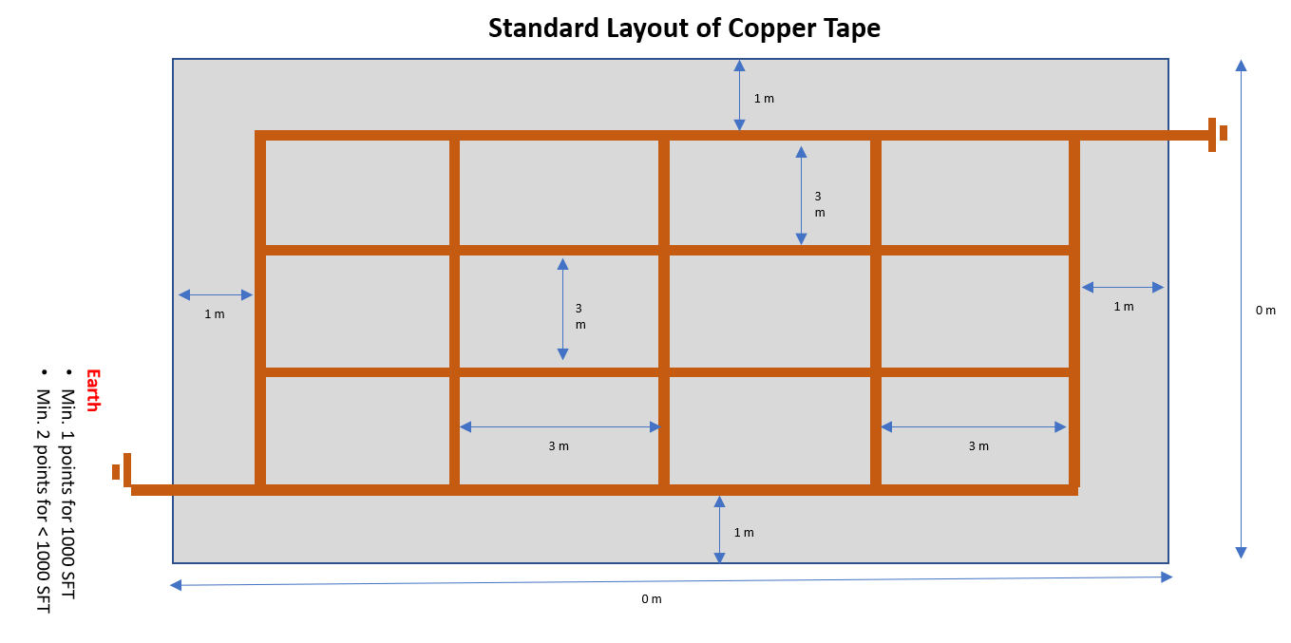

3.7 APPLICATION OF DUR-A-STATIC 100

- Pack components are pre-weighed for optimum performance. Never split or proportion packs.

- Stir Hardener B to re-disperse any settlement. Agitate Base A well and transfer to the mixing barrel and mix for 2 minutes while scraping at the side to homogenize mix.

- Immediately after mixing, spread Dur-A-STATIC 100 Conductive using a squeegee and a roller, ensuring a uniform coverage at 380 sf per gallon (this coverage rate is crucial).

- 24 hours after application, measure the conductivity of the coating with an Automated Prostat PRS-812 Surface Resistance Meter Set with two 5lb, Prostat probes (As per ASTM Specification) or approved equivalent.

- Dur-A-STATIC 100 when tested must have an average resistance of less than 1.5 kilo Ohms 1.5 x 10³ Ohms) with no individual measurements value more than 1.5 kilo Ohms (1.5 x 10³ Ohms).

  - APPLICATION OF DUR-A-STATIC 535 SL CONDUCTIVE

NOTE: DUR-A-STATIC 535 SL CONDUCTIVE should only be applied if DUR-A-STATIC 100 meets the above resistance requirements. Any readings that are out of the range need to be re-primed with DUR-A-STATIC 100. Consult Durabond for further information.

  - DUR-A-STATIC 535 SL comes in a kit with components that are pre-packed and pre-weighed for optimum performance. Never split or proportion packs.

  - Stir Part A (base) to re-disperse any settlement. Add Hardener B to the Base A container. Mix with a slow speed power mixing drill (maximum 450 rpm) and helical non-air entertaining mixer for 20 seconds taking care not to entrain air. Add filler C and continue to mix for 1.5 minutes to a maximum of times of 2 minutes. Take care not to entrain air.

  - Immediately after mixing, apply the DUR-A-STATIC 535 SL Conductive using a 12mm (1/2”) notched squeegee to control application thickness followed by steel trowel or cam rake (set at 12mm) to smooth the surface, and immediately finishing with a spiked roller to release any entrapped air.

  - 15-20 minutes later, dependent on temperature, roll the surface with a fine spike roller to remove air from the surface, taking care not to disturb the filler settlement.

  - TESTING
- Testing should be carried out as per standard using an Automated Prostat PRS-812 Surface Resistance Meter Set with two 5lbs, Prostat Probes (As per ASTM Specification) or approved equivalent.

  - TRAFFICKING
- Allow to cure for 24 hours at a minimum of 10°C before allowing light traffic. Full traffic is permitted after 72 hours.

  - CLEANING

- Wash all tools and equipment immediately with mineral Xylene or solvent-based cleaner. Allow any unused product to harden in container and discard according to local regulations.

  - Protection of Work

- Maintain a dust-free environment for the duration of work and until coating has fully cured.

- Erect suitable barriers to prevent floor treatment or other trades from entering working area during installation of coating and protect adjacent surfaces from damage.

- Do not proceed with application of materials immediately prior to, during, or immediately after inclement conditions, nor if adverse weather is anticipated within 24 hours after application.

- Do not apply finish coat in areas where dust is being generated.

- Protect applied coating from rapid evaporation during dry and hot weather. Consult Durabond Technical Services for recommendations should adverse conditions exist.

END OF SECTION

